**PRACTICAL-1:- LIST IN HTML**

**OUTPUT**

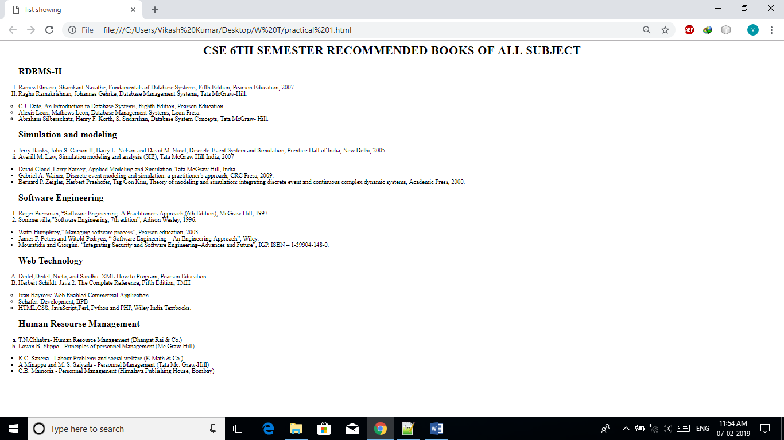

**PRACTICAL-1:- LIST IN HTML**

**CODE**

<HTML>

<HEAD>

<TITLE>LIST SHOWING</TITLE>

</HEAD>

<BODY >

<CENTER><H1>CSE 6TH SEMESTER RECOMMENDED BOOKS OF ALL SUBJECT </H1></CENTER>

<BLOCKQUOTE><H2>RDBMS-II</H2></BLOCKQUOTE>

<OL TYPE="I">

<LI>RAMEZ ELMASRI, SHAMKANT NAVATHE, FUNDAMENTALS OF DATABASE SYSTEMS, FIFTH EDITION, PEARSON EDUCATION, 2007.</LI>

<LI>RAGHU RAMAKRISHNAN, JOHANNES GEHRKE, DATABASE MANAGEMENT SYSTEMS, TATA MCGRAW-HILL.</LI>

</OL>

<UL TYPE="CIRCLE">

<LI>C.J. DATE, AN INTRODUCTION TO DATABASE SYSTEMS, EIGHTH EDITION, PEARSON EDUCATION</LI>

<LI>ALEXIS LEON, MATHEWS LEON, DATABASE MANAGEMENT SYSTEMS, LEON PRESS.</LI>

<LI>ABRAHAM SILBERSCHATZ, HENRY F. KORTH, S. SUDARSHAN, DATABASE SYSTEM CONCEPTS, TATA MCGRAW-

HILL.</LI>

</UL>

<BLOCKQUOTE><H2>SIMULATION AND MODELING</H2></BLOCKQUOTE>

<OL TYPE="I">

<LI>JERRY BANKS, JOHN S. CARSON II, BARRY L. NELSON AND DAVID M. NICOL, DISCRETE-EVENT SYSTEM AND

SIMULATION, PRENTICE HALL OF INDIA, NEW DELHI, 2005</LI>

<LI>AVERILL M. LAW, SIMULATION MODELING AND ANALYSIS (SIE), TATA MCGRAW HILL INDIA, 2007</LI></OL>

<UL TYPE="SQUARE">

<LI>DAVID CLOUD, LARRY RAINEY, APPLIED MODELING AND SIMULATION, TATA MCGRAW HILL, INDIA</LI>

<LI>GABRIEL A. WAINER, DISCRETE-EVENT MODELING AND SIMULATION: A PRACTITIONER'S APPROACH, CRC PRESS,

2009.</LI>

<LI>BERNARD P. ZEIGLER, HERBERT PRAEHOFER, TAG GON KIM, THEORY OF MODELING AND SIMULATION:

INTEGRATING DISCRETE EVENT AND CONTINUOUS COMPLEX DYNAMIC SYSTEMS, ACADEMIC PRESS, 2000.</LI></UL>

<BLOCKQUOTE><H2>SOFTWARE ENGINEERING</H2></BLOCKQUOTE>

<OL TYPE="1">

<LI>ROGER PRESSMAN, “SOFTWARE ENGINEERING: A PRACTITIONERS APPROACH,(6TH EDITION), MCGRAW HILL,

1997.</LI>

<LI>SOMMERVILLE,”SOFTWARE ENGINEERING, 7TH EDITION”, ADISON WESLEY, 1996.</LI></OL>

<UL TYPE="">

<LI>WATTS HUMPHREY,” MANAGING SOFTWARE PROCESS”, PEARSON EDUCATION, 2003.</LI>

<LI>JAMES F. PETERS AND WITOLD PEDRYCZ, “ SOFTWARE ENGINEERING – AN ENGINEERING APPROACH”, WILEY.</LI>

<LI>MOURATIDIS AND GIORGINI. “INTEGRATING SECURITY AND SOFTWARE ENGINEERING–ADVANCES AND FUTURE”,

IGP. ISBN – 1-59904-148-0.</LI></UL>

<BLOCKQUOTE><H2>WEB TECHNOLOGY</H2></BLOCKQUOTE>

<OL TYPE="A">

<LI>DEITEL,DEITEL, NIETO, AND SANDHU: XML HOW TO PROGRAM, PEARSON EDUCATION.</LI>

<LI>HERBERT SCHILDT: JAVA 2: THE COMPLETE REFERENCE, FIFTH EDITION, TMH</LI></OL>

<UL TYPE="CIRCLE">

<LI>IVAN BAYROSS: WEB ENABLED COMMERCIAL APPLICATION</LI>

<LI>SCHAFER: DEVELOPMENT, BPB</LI>

<LI>HTML,CSS, JAVASCRIPT,PERL, PYTHON AND PHP, WILEY INDIA TEXTBOOKS.</LI></UL>

<BLOCKQUOTE><H2>HUMAN RESOURSE MANAGEMENT</H2></BLOCKQUOTE>

<OL TYPE="A">

<LI>T.N.CHHABRA- HUMAN RESOURCE MANAGEMENT (DHANPAT RAI & CO.)</LI>

<LI>LOWIN B. FLIPPO - PRINCIPLES OF PERSONNEL MANAGEMENT (MC GRAW-HILL)</LI></OL>

<UL TYPE="SQUARE">

<LI>R.C. SAXENA - LABOUR PROBLEMS AND SOCIAL WELFARE (K.MATH & CO.)</LI>

<LI>A MINAPPA AND M. S. SAIYADA - PERSONNEL MANAGEMENT (TATA MC. GRAW-HILL)</LI>

<LI>C.B. MAMORIA - PERSONNEL MANAGEMENT (HIMALAYA PUBLISHING HOUSE, BOMBAY)</LI>

</UL>

</BODY>

<HTML>

**PRACTICAL-2: TABLE IN HTML**

**OUTPUT**

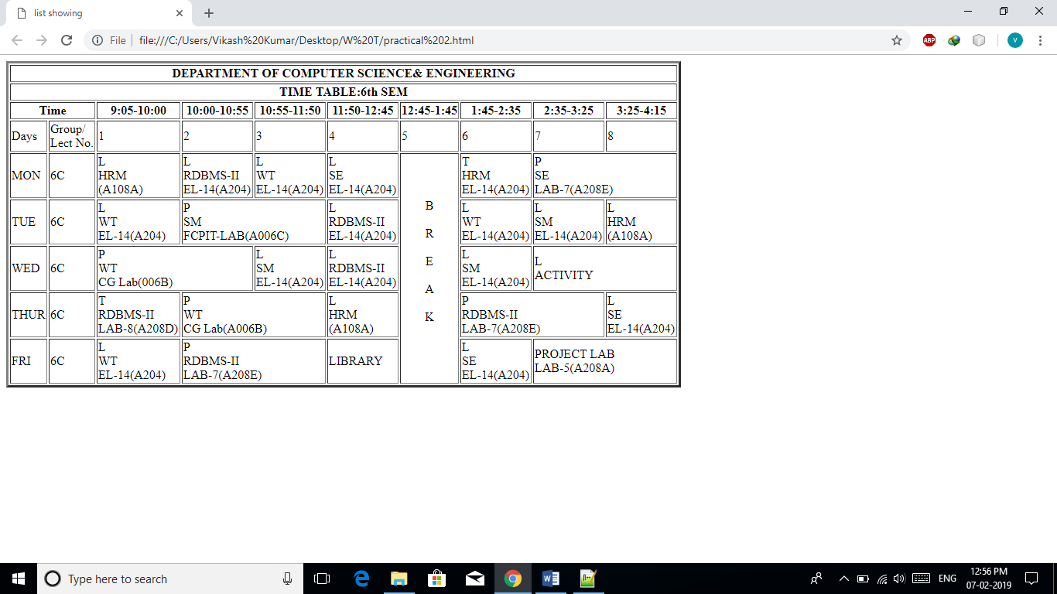

**PRACTICAL-2: TABLE IN HTML**

**CODE**

<HTML>

<HEAD>

<TITLE>LIST SHOWING</TITLE>

</HEAD>

<BODY >

<TABLE BORDER="3" >

<TR>

<TH COLSPAN="10">DEPARTMENT OF COMPUTER SCIENCE& ENGINEERING</TH>

</TR>

<TR>

<TH COLSPAN="10">TIME TABLE:6TH SEM</TH>

</TR>

<TR >

<TH COLSPAN="2">TIME</TH>

<TH>9:05-10:00</TH>

<TH>10:00-10:55</TH>

<TH>10:55-11:50</TH>

<TH>11:50-12:45</TH>

<TH>12:45-1:45</TH>

<TH>1:45-2:35</TH>

<TH>2:35-3:25</TH>

<TH>3:25-4:15</TH></TR>

<TR>

<TD >DAYS</TD>

<TD >GROUP/<BR>LECT NO.</TD>

<TD>1</TD>

<TD>2</TD>

<TD>3</TD>

<TD>4</TD>

<TD >5</TD>

<TD>6</TD>

<TD >7</TD>

<TD>8</TD></TR>

<TR>

<TD >MON</TD>

<TD >6C</TD>

<TD>L<BR>HRM<BR>(A108A)</TD>

<TD>L<BR>RDBMS-II<BR>EL-14(A204)</TD>

<TD>L<BR>WT<BR>EL-14(A204)</TD>

<TD>L<BR>SE<BR>EL-14(A204)</TD>

<TD ROWSPAN="5" ><CENTER>B<BR><BR>R<BR><BR>E<BR><BR>A<BR><BR>K<BR><BR></CENTER></TD>

<TD>T<BR>HRM<BR>EL-14(A204)</TD>

<TD COLSPAN="2">P<BR>SE<BR>LAB-7(A208E)</TD></TR>

<TR>

<TD >TUE</TD>

<TD >6C</TD>

<TD>L<BR>WT<BR>EL-14(A204)</TD>

<TD COLSPAN="2">P<BR>SM<BR>FCPIT-LAB(A006C)</TD>

<TD>L<BR>RDBMS-II<BR>EL-14(A204)</TD>

<TD>L<BR>WT<BR>EL-14(A204)</TD>

<TD>L<BR>SM<BR>EL-14(A204)</TD>

<TD>L<BR>HRM<BR>(A108A)</TD></TR>

<TR>

<TD >WED</TD>

<TD >6C</TD>

<TD COLSPAN="2">P<BR>WT<BR>CG LAB(006B)</TD>

<TD>L<BR>SM<BR>EL-14(A204)</TD>

<TD>L<BR>RDBMS-II<BR>EL-14(A204)</TD>

<TD>L<BR>SM<BR>EL-14(A204)</TD>

<TD COLSPAN="2">L<BR>ACTIVITY</TD></TR>

<TR>

<TD >THUR</TD>

<TD >6C</TD>

<TD>T<BR>RDBMS-II<BR>LAB-8(A208D)</TD>

<TD COLSPAN="2">P<BR>WT<BR>CG LAB(A006B)</TD>

<TD>L<BR>HRM<BR>(A108A)</TD>

<TD COLSPAN="2">P<BR>RDBMS-II<BR>LAB-7(A208E)</TD>

<TD>L<BR>SE<BR>EL-14(A204)</TD></TR>

<TR>

<TD >FRI</TD>

<TD >6C</TD>

<TD>L<BR>WT<BR>EL-14(A204)</TD>

<TD COLSPAN="2">P<BR>RDBMS-II<BR>LAB-7(A208E)</TD>

<TD>LIBRARY</TD>

<TD>L<BR>SE<BR>EL-14(A204)</TD>

<TD COLSPAN="2">PROJECT LAB<BR>LAB-5(A208A)</TD></TR>

</TABLE>

</BODY></HTML>

**PRACTICAL-3:-FRAME IN HTML**

**OUTPUT**

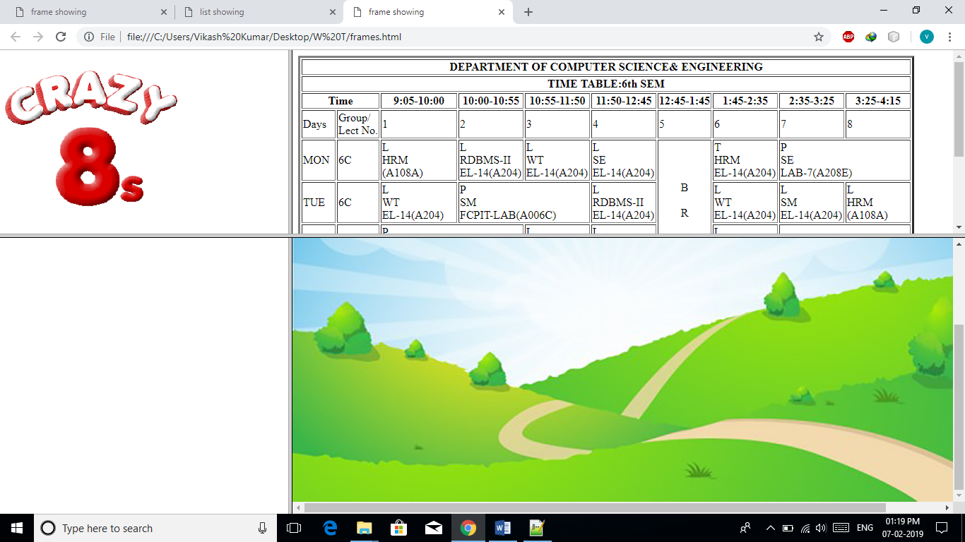

**PRACTICAL-3:-FRAME IN HTML**

**CODE**

<HTML>

<HEAD>

<TITLE>FRAME SHOWING</TITLE>

</HEAD>

<FRAMESET ROWS="40%,60%" COLS="30%,70%">

<FRAME NAME="F1" SRC="CRAZY_EIGHT.PNG" ></FRAME>

<FRAME NAME="F2" SRC="PRACTICAL 2.HTML"></FRAME>

<FRAME></FRAME>

<FRAME SRC="C:\USERS\VIKASH KUMAR\DESKTOP\BACKGROUNDS.PNG"></FRAME>

</FRAMESET>

</HTML>